DISCRETE Hybrid wavelet TRANSFORMS and

their use for image compression.

Radoslav Vargic, Department of telecommunications, FEI STU,
Ilkovičova 3, 812 19 Bratislava, Slovakia
E-mail: vargic@ktl.elf.stuba.sk,
Tel.: ++421-7-5879412, fax: ++421-7-65420227

Abstract

In this article we describe the ways how to construct discrete hybrid wavelet transforms (HWT), i.e. generalisation of discrete wavelet transforms (DWT) where basis is created by mixing 2 or more bases of existing DWT. General properties of HWT are discussed. To compare their performance and properties to the classical systems, an application for image compression using progressive image coder is given.

Keywords: wavelets, hybrid systems, image compression, progressive coding

1. Introduction

Wavelets [1][2] became popular in few past years in mathematics and digital signal processing area because of their ability to effectively represent and analyse data. There are many generalisations of original orthogonal wavelet systems [2]. In addition to construct more general wavelet system, there exist also considerable effort to optimise filter sets of underlying filter banks (FB) [3]. In this article we want to adapt existing filter sets of various wavelets to construct more general transform than DWT by mixing together bases of several DWT. Such approach we call hybridisation and to the resulting transform we refer as discrete hybrid wavelet transform (HWT).
Typical application of wavelets in digital signal processing is image compression. (mostly lossy case) [1]. Because of their multiresolution signal representation they are the best candidate for progressive transmission coding (e.g. SPIHT [4], CREW [5]). Recent compression methods based on wavelet approach are very successful when comparing to other methods based on block transforms, fractals or neural nets [1][6][7][8].

2. Classical wavelet systems

Wavelet bases are built from one base wavelet function 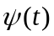 (orthogonal case), two base wavelets 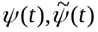 (biorthogonal case) or more (multiwavelets) by operations shift and scaling [1][2]. All these classical wavelet systems have the same properties across the scales and when used as separable transform also the same properties in different directions. In the simplest (orthogonal/biorthogonal) case then for scaling functions 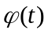 holds:
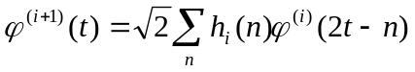 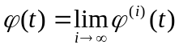 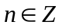 (1)
where 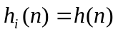 are interscale coefficients, interpreted as impulse response 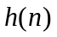of protype low-pass synthesis FIR filter in associated FB (Fig.1) [1]. Analogicaly we can construct remaining scaling function and wavelets with their duals 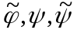 using FB filter impulse responses 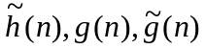. Decomposition and reconstruction relations then are [1]:
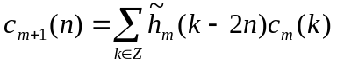 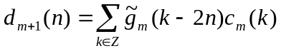 (2)
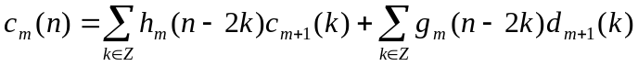 (3)
where
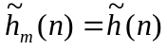 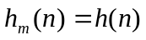 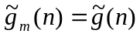 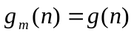 (4)
means decomposition level, 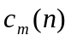, 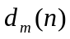 are scaling and wavelet coefficients. Recently DWT computations are performed mostly by lifting scheme witch has in addition to spedd-up also many interesting properties, e.g. in-place calculation, integer DWT [11] .

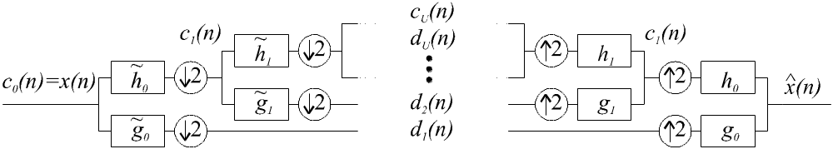

Fig.1: DWT computation using 2 band Filter Bank.

3. Hybrid wavelets

Basis of HWT is produced by mixing bases of several DWT. Thus basis functions are not simple dilatations and translations of one prototype function. Basis structure is more complex, and has more degrees of freedom. We can distinguish two basic types of mixing wavelet bases (hybridisation):

- Mixing bases in separable multidimensional wavelet transforms, using different wavelets in different directions (dimensions). This brings us to the ideas of directional wavelets [10], which can perform better in images witch have different properties in different directions.
- Mixing bases in one direction by using different wavelets at different scales, e.g. having different interscaling coefficients in different decomposition levels

Using both hybridisation types we get new bases with properties, that we can affect by choosing appropriate wavelets and type of mixing. These types are not mutually exclusive, so we can combine them in one hybrid wavelet system too. We can apply them also to many generalisations of wavelets (e.g. biorthogonal wavelets, wavelet packets).
Case a) is trivial and usable only when using separable decomposition. This case is suitable when input data have different character in directions x and y, or when we want to give priority to the transform to decorrelate in some special directions better. Properties of such hybrid systems are straightforward. In case of orthogonal Block transform such hybrid systems were described in [9].
Case b) is more appropriate, when we expect data to have different behaviour at different scales, i.e. in different decomposition levels. Then we can try to choose in that levels (m) more suitable set of interscale coefficients 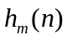,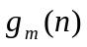,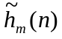,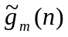. From matrix notation of corresponding decimation/interpolation operations (2) (3) is easy to see, that relations of orthogonality or biorthogonality between coefficients at different scales in such mixed wavelet system remain intact [10]. As interscale coefficient at different decomposition levels are coupled in “serial“ manner, conditions on regularity and vanishing/preserved moments are more complicated, and depend mostly on the worse set of interscaling coefficients used (in the sense of regularity, moments). More important it showed shape of resulting base functions, as stated in [3]. Examples of bases of HWT are depicted in Fig.2. There are two important general properties that we will to point out:

- Interscale coefficients in small decomposition levels (at the beginning) affect mostly local behaviour of basis functions (“anomalies”), interscale coefficients at higher levels mostly affect whole character (“trends”) in basis functions.
- When we use different interscale coefficients only in level say L, these presents only local anomaly at given scale, and after sufficient number of successive iterations, converge basis functions (1) to the same functions as without this anomaly in
level L.

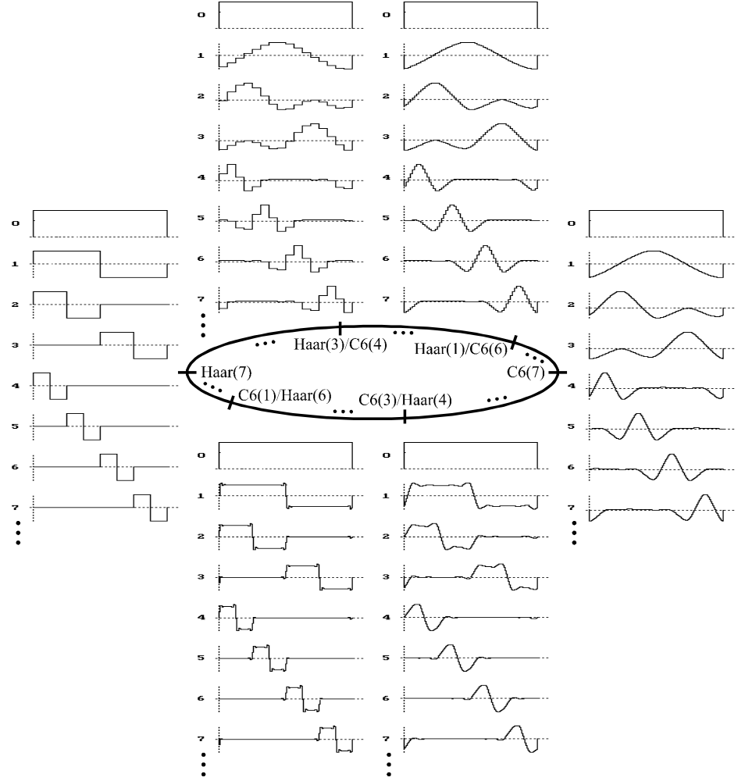

Fig.2: Basis functions of Hybrid wavelet transform Coiflet6-Haar (HWT type 2). Depicted first 8 from all 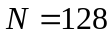 basis functions. Remark.: (x)= number of decomposition steps made with given wavelet.

4. Image compression using hybrid wavelets

In wavelet coders is mostly used 2D separable DWT with non-standard decomposition [1]. Application of HWT of type 1 is then trivial, i.e. different wavelets in x and y direction are used. We focus here on HWT type 2 and show how they can be useful.
For coding purposes we adapt progressive coder SPIHT [4] to incorporate with hybrid wavelets. Many hybrid wavelet systems were tested, but without any type of hybridisation parameter optimisation. As an typical example for comparison we used SPIHT's original filter set (known as FBI 9/7 filters [2]) and his hybridised version with Haar wavelet.

Picture  name | Bit  rate  [bpp] | Peek signal to noise ratio (PSNR) [dB]
Picture  name | Bit  rate  [bpp] | FBI 9-7 | Haar | HWT FBI 9/7 + Haar |  |  | HWT Haar + FBI 9/7
 |  |  |  | (1)/(5) | (2)/(4) | (3)/(3) | (1)/(5) | (2)/(4) | (3)/(3)
geometry | 0.5 | 39.25 | 73.67 | 46.14 | 52.65 | 62.28 | 44.01 | 40.78 | 39.69
geometry | 0.25 | 31.11 | 38.40 | 33.11 | 33.73 | 35.34 | 32.60 | 31.72 | 31.36
geometry | 0.1 | 24.63 | 23.79 | 24.43 | 23.70 | 23.40 | 24.79*⁾ | 25.0*⁾ | 24.8*⁾
geometry | 0.05 | 21.52 | 20.27 | 20.80 | 20.52 | 20.23 | 21.41 | 21.56*⁾ | 21.51
geometry | 0.01 | 15.99 | 14.43 | 16.03*⁾ | 15.84 | 15.2 | 14.63 | 15.08 | 15.50
text | 2 | 31.53 | 50.37 | 32.64 | 31.70 | 31.63 | 38.77 | 46.01 | 50.25
text | 1 | 21.25 | 22.93 | 21.53 | 24.40*⁾ | 21.31 | 21.73 | 22.83 | 22.91
text | 0.5 | 16.06 | 15.60 | 16.12*⁾ | 16.18*⁾ | 16.04 | 15.58 | 15.60 | 15.65
text | 0.25 | 13.34 | 12.80 | 13.31 | 13.36*⁾ | 13.34 | 12.82 | 12.85 | 12.85
text | 0.1 | 11.68 | 11.42 | 11.57 | 11.69*⁾ | 11.70*⁾ | 11.61 | 11.43 | 11.42


Tab.1: Results for image compression of synthetic images using two DWT and their hybrids coupled with SPIHT algorithm. Remark: (x/y)=number of decomposition steps made with (first/second) wavelet coefficient set in HWT; *⁾ indicate, that HWT is more effective than both its origins

Fig.3: Comparison of compression efficiency in the sense of PSNR for FBI 9/7 and Haar wavelets and some their mutual HWT using image "text". Remark: On the graph are shown only PSNR differences against PSNR for FBI 9/7 wavelet.
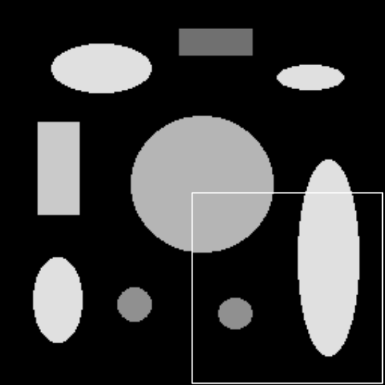 | 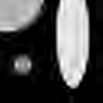 | 
 | a) FBI (6) | b) FBI (2) + Haar (4)
 | 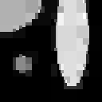 | 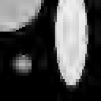
picture "geometry" | c) Haar (6) | d) Haar (2) + FBI (4)
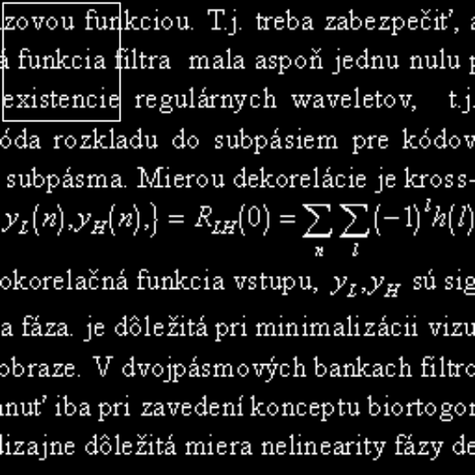 |  | 
 | a) FBI (6) | b) FBI (3) + Haar (3)
 |  | 
picture "text" | c) Haar (6) | d) Haar (3) FBI (3)

Fig 4.: Compression of test images with SPIHT algorithm using FBI 9/7 and Haar wavelets and their mutual hybrids. In a)-d) bpp=0.05, in e)-h) bpp=0.5. Remark.: Corresponding PSNR values are in Tab.1; (x)= number of decomposition steps made with given wavelet coefficients

In Table 1, Fig. 3 and Fig. 4 we can see results when applying these DWT to synthetic image compression. The results for standard natural test images show the same character but are less demonstrative. Used synthetic images have sharp edges, so common wavelets (e.g. FBI 9/7) will be not very efficient. Viewing HWT as modification of original wavelet (FBI 9/7) we see, that with simple hybridisation we can achieve better results in wide compression ratio range. Mostly has resulting hybrid wavelet transform the PSNR value somewhere between original wavelet and wavelet with we hybridise (modify), but sometimes resulting HWT is the most effective. PSNR results are compared in graph in Fig. 3 and resulting image degradation we can visually observe in Fig. 4.

5. Conclusion

In this article we presented one generalisation of discrete wavelet transform using hybridisation. This way can be constructed from existing DWT many others HWT, that can have properties optimised to given purposes. This process can be run adaptively or can be used statically for given classes of images. We did not optimise process of HWT basis selection, this will be topic for further work. Only concept and properties were presented. In example for image compression using progressive coding algorithm we showed that proposed wavelet transforms have some potential. This could be further exploited with proper adaptation/optimisation mechanism.

6. Literature

[1] Vetterli, M., Kovačević, J.: Wavelets and Subband Coding, Prentice Hall, 1995.
[2] Burrus, S., C., Gopinath, A., Guo, H.: Introduction to Wavelets and Wavelet Transforms, Prentice Hall, 1998.
[3] Villasenor, J.,D., Belzer, B., Liao, J.: Wavelet filter evaluation for Image compression, IEEE Transactions on processing, Vol. 4, August 1995.
[4] Said, A., Pearlman, W. A.: A new fast and efficient image codec on set partitioning in hierarchical trees, IEEE Trans.on Circuits Syst. Video Tech., vol. 6, pp. 243-250, June 1996
[5] Gormish, J., Schwartz, E., Boliek, M., Zandi, A., Keith, A.: Lossless and nearly lossless compression for high quality images, Proc. of IS&T/SPIE's 9th Annual Symposium, Vol. 3025, San Jose, February 1997.
[6] Davis, G., Nosratinia, A.: Wavelet-based Image Coding: An Overview, Applied and Computational Control, Signals, and Circuits, Vol. 1, No. 1, Spring 1998.
[7] Rinaldo, R., Calvagno, G.: Image Coding by Block Prediction of Multiresolution Subimages, IEEE Transaction on Image Processing, Vol. 4, No. 7, str.909-920, July 1995.
[8] Oravec, M., Podhradský, P.: Image compression Using Neural Networks, Journal of Electrical Engineering, 46, No. 9, Bratislava, 1995
[9] Polec, J.: Non standard methods in use of discrete orthogonal transforms for data compression, Dissertation thesis, FEI STU, Bratislava, 1993
[10] Vargic, R.: Compression of static images using wavelet transform and lifting scheme, Ph.D. Thesis, FEI STU, Bratislava, February 1999
[11] Daubechies, I., Sweldens, W.: Factoring Wavelet Transforms Into Lifting Steps, J. Fourier Anal. Appl., Vol. 4, Nr. 3, pp. 247-269, 1998.

